**Cyclin B Images**

The behaviour of Cyclin B (red) at different stages of the cell cycle (marked by microtubules in green) in late developmental Drosophila embryo (Huang’s lab).

**Cell Cycle Images**

Cell cycle progresses in Drosophila syncytial embryo. Red: Chromosomes; Green: Microtubules (Huang’s lab)

**Normal Cell Cycle Progression**

The primary function of the cell cycle is to accurately duplicate chromosomal DNA and segregate the copied DNA into two genetically identical daughter cells. These two processes define the major phases of the mammalian cell cycle; S phase (or synthesis phase), and M phase (Mitosis). Mitosis itself consists of nuclear division (true mitosis) brought about by the complex machinery of the mitotic spindle, and cytoplasmic division (cytokinesis). Within the cell cycle, two major checkpoints exist, to prevent cell progression in the presence of DNA damage and to prevent the onset of anaphase in the presence of misaligned chromosomes.

***M Phase***

M phase is comprised of 5 principle stages (Alberts et al., 2002) beginning with Prophase. Here, the replicated chromosomes condense and the mitotic spindle assembles outside of the nucleus, between the two centrosomes. Prometaphase then begins with nuclear envelope breakdown, allowing chromosomes to attach spindle microtubules via kinetochores. The chromosomes are then aligned at the spindle equator, between the spindle poles and sister chromatids and are attached to opposite poles of the spindle via kinetochore microtubules. This phase is referred to as metaphase. During the fourth phase of mitosis, anaphase, the sister chromatids are separated into the two sister chromosomes, kinetochore microtubules shorten and spindle poles move apart to bring about chromosome segregation. The cell then moves into telophase, where the two sets of daughter chromosomes reach opposite poles of the cell and once there, condense. At this stage a new nuclear envelope forms around each set of segregated chromosomes, completing the formation of two daughter nuclei containing a diploid complement of chromosomes identical to that of the parent cell, marking the completion of mitosis. Following mitosis, the final stage of cell division is cytokenisis, or division of the cytoplasm which "pinches" the cell into two independent cells, each with their own identical nuclei. This series of events must always proceed in the stated order, and mechanisms exist to ensure that the cell cycle cannot continue to the next stage without successful completion of the previous stage.

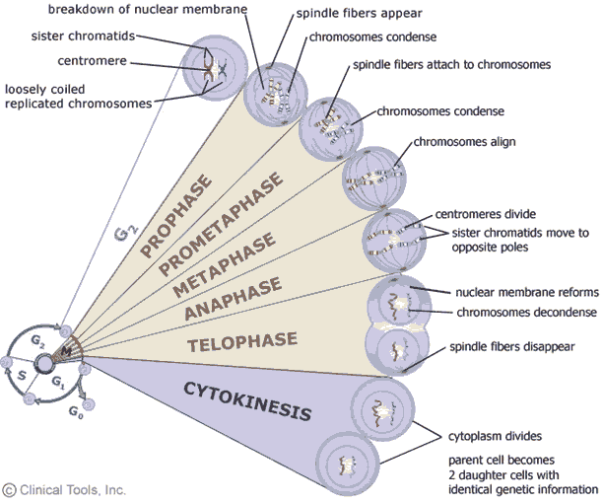

**Introduction to the Mitotic Spindle Assembly Checkpoint**

Referred to as the "guardian of the genome" (Iwanaga and Jeang, 2002) the SAC ensures that all chromosomes are properly aligned at the metaphase plate before the cell cycle is allowed to progress to anaphase. This ensures that premature sister chromatid separation is avoided, and so daughter cells receive an equal and identical chromosome compliment. So why is this checkpoint so important? Chromosome instability and aneuploidy (abnormal chromosome number) has profound effects (Hassold and Hunt, 2001) and is linked to various cancers (Yuen et al., 2005). The SAC is critical in the preservation of euploidy (normal chromosome number), loss of which is a common characteristic of cancer cells, contributing to their malignant progression (Weaver and Cleveland, 2006, Weaver et al., 2006). Loss or downregulation of SAC components have been reported in a number of cancer cell lines. An example of such a component is the SAC protein Mad2. Mutation of SAC component Mad2 has been linked to diseases including gastric cancer (Kim et al., 2005) and has been found to be downregulated in cancer cell lines. With links between kinetochore dysfunction and cancer (Li and Benezra, 1996), the importance of the SAC in human disease is becoming ever more apparent. SAC components are commonly being researched as potential gene therapy targets where downregulated in cancer cell lines (Morozov et al., 2007) , as well as targets for anti-tumour therapies due to the lethality of cells with complete loss of checkpoint function (Kops et al., 2005).

**The DNA Damage Checkpoint: A Brief Overview**

The DNA damage response, or DNA damage checkpoint, acts at G1/S as well as within S-phase and G2/M (but not in mitosis) to block the cell cycle in the presence of any potentially lethal genetic errors which may result from chromosomal DNA damage. A highly conserved surveillance mechanism triggers a cascade of events which coordinate the repair of the detected lesion with cell cycle arrest. The checkpoint is only satisfied once the offending lesion has been successfully removed and repaired. Failure of the cell to detect DNA damage can have catastrophic effects, and has been linked to increased cancer susceptibility.

DNA damage can present itself in various forms. The nucleotides of DNA are continuously subject to modification by hydrolysis and oxidation reactions, these can lead to the introduction of genetic error of a number of types. External environmental factors can also contribute to genetic modification, such as exposure to ultraviolet (UV) radiation (Freedman et al., 1991).

Alterations in DNA structure most commonly affect one DNA strand at a given site, resulting in a single strand break (ssb), however, it is possible for both strands of the DNA to be disrupted, resulting in a double strand break (dsb). Because breaks in DNA are capable of fragmenting chromosomes and can often lead to chromosomal rearrangements if the DNA repair machinery accidently fuses broken DNA ends from different chromosomes, they are potentially very harmful and so must be repaired.

The DNA damage checkpoint does not respond to all genetic errors within chromosomal DNA, it only becomes active when the normal routes of DNA repair are unable rectify the problem, or the damage has caused replication forks to stall and produce abnormal DNA structures. In eukaryotes the DNA damage response is under the control of two members of the phosphoinositide three-kinase-related kinase family (PIKK) (Zhang et al., 2006), ATM and ATR, (Barr et al., 2003, Cimprich and Cortez, 2008, Lovejoy and Cortez, 2009)

ATM is specialised to the repair of double-strand breaks (dsb), and it’s activation is required for checkpoint activation in response to these breaks (Shiloh, 2003, Pereg et al., 2006). ATR is also required for checkpoint activation in response to dsb’s, but is also responsible for a number of other responses, such as those to nucleotide damage (ssb’s) and stalled replication forks (Zhang et al., 2006). The specific recruitment of either ATM or ATR to sites of DNA damage is believed to be due to their localisation requiring different proteins or complexes. In the case of ATR, recruitment is believed to be via a protein named RPA, whereas ATM recruitment to dsb’s is believed to be in response to its activation by binding of the MRN complex (Jazayeri et al., 2006) Once recruited, the ATM and ATR can initiate the DNA damage response, halting the cell cycle and initiating the relevant repair mechanisms.

Simple nucleotide alterations (single strand breaks) can be repaired by two systems; the first is base excision repair (BER) the second system is nucleotide excision repair. Double stranded breaks can be repaired by two mechanisms, non-homologous end joining (NHEJ) and homologous recombination. If repair mechanisms are unable to rectify DNA damage, the block on cell cycle progression may never be lifted, or more commonly, the cell will be subject to death by apoptosis.

**The Eukaryotic cell cycle is highly ordered and tightly regulated**

The cell cycle consists of a highly ordered sequence of biochemical events, triggered in a specific order and at specific time points. This control system is tightly regulated by a number of key components, mainly the cyclin-dependent kinases (Cdks). These biochemical switches control the transitions of the cell cycle through three main phases; cell cycle start, defining entry into the cycle at late G1 phase, and the two cell cycle checkpoints; the G2/M checkpoint (controlling entry into mitosis), and the spindle assembly checkpoint (SAC) which controls the metaphase to anaphase transition.